www.nwr.org.uk/
BOOKHAM, SURREY
Autumn 2021
Meetings are usually on Wednesdays and start at 8pm unless stated otherwise
15 SEPTEMBER | What’s on your bucket list? We all know how difficult this year has been. In a few words tell us what you had to cancel/change and if you have now rearranged it, maybe differently. Did you take up a hobby that you will be continuing? Any lifestyle changes you have made over the last year that you want to share? Maybe you enjoyed lockdown, an excuse to avoid all the annoying relatives?! | 8pm  United Reformed Church £3 per person
29 SEPTEMBER | Visit to Passion For Plants - East Horsley  A talk, tour of the farm, a floristry  demonstration and cup of tea. Please let Jane Guillem know if you are coming if you haven’t done so already | 2PM  £6 per person
Monday 11th 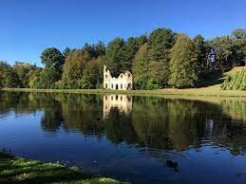OCTOBER | Autumn at Painshill Park.  An introductory tour of Painshill Park led by Michele Howes. The visit also includes a guide book and tea/coffee  £12.50 per person (non members)  £5 per person (members) | Meet at 10.00am at the entrance
20 OCTOBER | Jenny Jackson (Deputy Chief Fundraiser) will speak to us about the work of the Debra charity. Join us on Zoom for a prompt 8 pm start. | 8PM  Zoom  £2 per person

3rd NOVEMBER  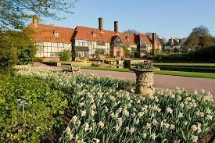 | A tour of the new area at Wisley Gardens. We have two tours available. One at 10.15am  (8 spaces) and another at 1.15pm (10 spaces). Please let Jane Guillem know which tour you would like to join and we will allocate on a first come first served basis. RHS members free and hopefully each member can bring in a guest. More info to follow. | Meet 15 mins before your tour at the entrance outside the gardens
17  NOVEMBER | Telephone Treasure Trail - Further details to  follow but we are hoping to hold this in the  United Reformed Church
8 DECEMBER | Christmas Celebration - an evening of festive fun!  We hope that this will take place in the United  Reformed Church Hall  Further details to follow nearer the time
TUESDAY  14 DECEMBER  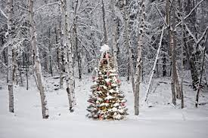 | A morning get together for those that are free at Polesden. Meet for a short walk around the gardens and house that we hope will be  decorated for Christmas. Finish with a coffee in the cafe | Meet 10.00am At the entrance

