Nine day trip on the Mississipi.
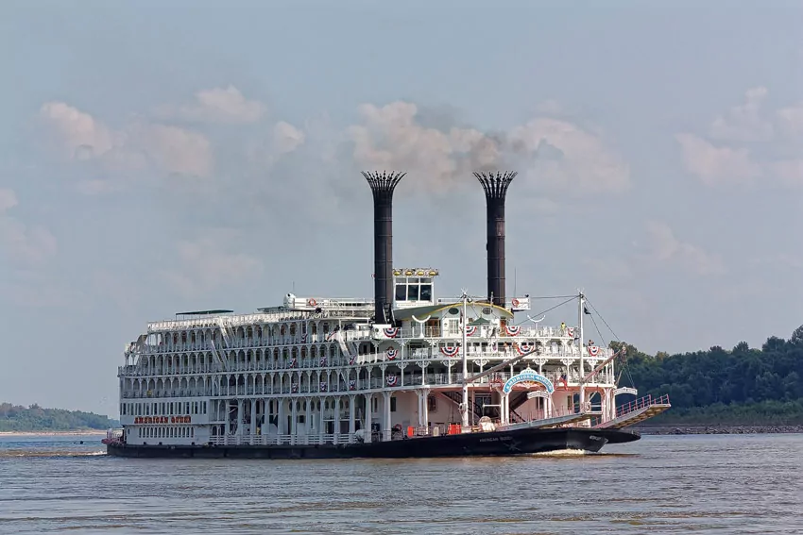 A few years, ago my very generous son treated me to a really memorable holiday to celebrate a special birthday. We went on a nine, day trip, down the Mississippi River starting in Memphis and ending in New Orleans
We travelled aboard the mock American Queen paddle steamer. Staying in one of the only two owner’s suites complete with our own butler!
We flew out to Memphis First Class and stayed there for a couple of days where we visited the famous Beale Street. (fabulous live music in all the bars). We also visited Graceland which is surprisingly modest considering who lived there. We went to the Sun Studios where Elvis made his first recordings.
It was a wonderful ‘step back in time’.
Following this we sailed along the river to Nachez, well known for its Antebellum mansions, which were, in the main, owned by wealthy plantations owners.
Another interesting stop was Vicksburg famous for the Battle of Vicksburg during the Civil War. However, top of my list was a day trip which took us down a bayou, where we saw alligators up close. Very thrilling!
Finally. we spent three brilliant days in New Orleans, exploring. We visited many amazing places but the two which stick in my mind are Bourbon Street -really noisy and fun, with great music (and scantily dressed women dancing) and the French Quarter, again with a vibrant street life and beautiful historic buildings.
I also mustn’t forget to mention the hospitality in the Deep South. Amazingly warm and friendly people, not to mention that southern drawl.
