Trip to Buenos Aires and Rio de Janeiro
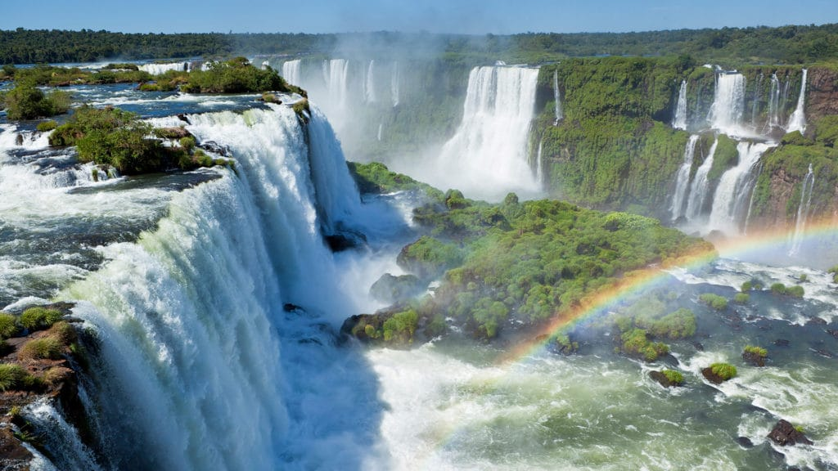
My memorable holiday was a trip to South America. Our main highlights were:
A week in Buenos Aires during which we had a day excursion to Uruguay on a large ferry crossing The Rio Del Plata or River Plate which is so wide it took about an hour. After our first week in Buenos Aires we flew to the Iguazu Falls which extend for miles straddling the borders between Argentina, Brazil and Paraguay. After a few days there we then went on to Rio de Janeiro where we journeyed up the Corcovado Mountain by miniature train. The statue of Christ the Redeemer is at the summit; mostly the top half of his body was obscure by floating clouds once we were up there … something the guide books don’t mention.
We also visited Sugarloaf Mountain as well as the sweeping panoramas of the bays which surround Rio.

