Kirsty M Brown
27 September 1974 - 22 July 2003

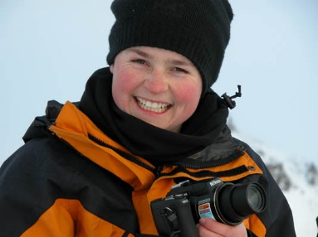
Kirsty, known as "Bang" to her family and friends, was born and brought up in Southwater, Sussex. She went to local schools, Coolham, Farlington and Collyers, where she developed her interest in Geology.
Kirsty was with the family on Safari in Botswana, when she received her A-level results over the bush radio, with the help of a Land Rover and convenient tree which were sufficiently good, to her surprise to secure a place at Royal Holloway, London. Some three years later, she emerged with a very good BSc 2.1.
Literally on the same day she received her degree, she left for Greenland to join an Imperial College team, looking for a curious limestone called Ikiate. The team were later awarded the Duke of Edinburgh prize for the British sub-aqua club for 1995. The award was given at Buckingham Palace in February, but Kirsty (who was by then doing an Msc in oceanography at Southampton University) was unable to get there because of snow!
After another working trip to Greenland for an oil company, Kirsty went on a hurried visit to New Zealand and Australia and accepted an offer to do a PhD at Adelaide University. Some four and a half years later, and still on her PhD subject of sea grass, she flew to England, to interview for the job of Marine Biologist at Rothera with BAS.
She over-wintered there for 8 months with her 22 good friends and was thoroughly enjoying life. On the last morning she saw the sun again for the first time.
Apart from work, Kirsty was a great horsewoman, winning a junior championship at Hickstead, was said to be a very good pools player, and could drink most people under the table. She also had a particular interest and talent for photography.
Posthumously and very unusually, Adelaide University awarded her a PhD for her work.
There is a memorial toposcope at Rothera Point with the following inscription, "Kirsty "Bang" Brown, 27/9/1974 - 22/7/2003 In such a short time she achieved so much and lived life to the full."
Commemorative place name: Kirsty Island is a small island just West of Lagoon Island and East of Léonie Island, in Ryder Bay, Adelaide Island which is named Kirsty Island. It has outcrops of reddish rocks. The island is used by scientists at Rothera Research Station as a site for marine research and recreation. 67° 35' 50" S 68° 16' 07" W
